HC 1 T2 U2
 | 題目 | 圖片
1 | Jump to the door. | 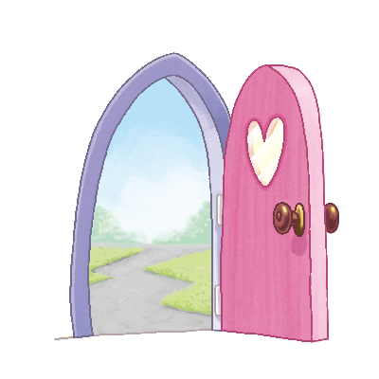
2 | Jump to the window. | 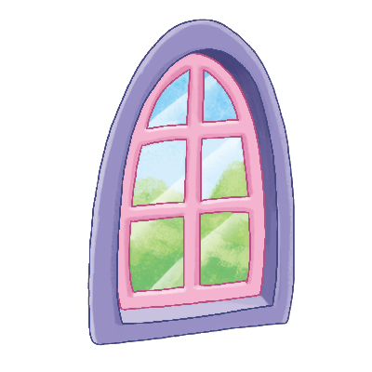
3 | Jump to the table. | 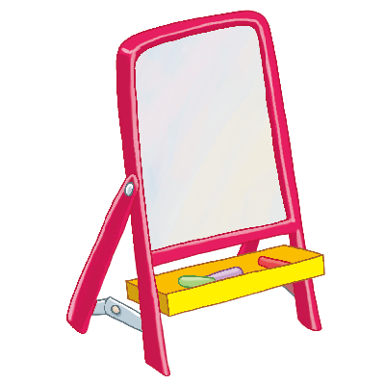
4 | Jump to the board. | 